Excersise No 3 : Didgiskill.pk : Data Anayltics

Task:
1. Create calculated columns:
• To categorize sales into High and Low based on the Sales value, where values greater than 100
are labeled as High and others as Low. Name the new column as Sales Category
• To classify records based on discount, label entries with zero discount as “No Discount” and
others as “Discount Applied”. Name the new column as Discount Category.

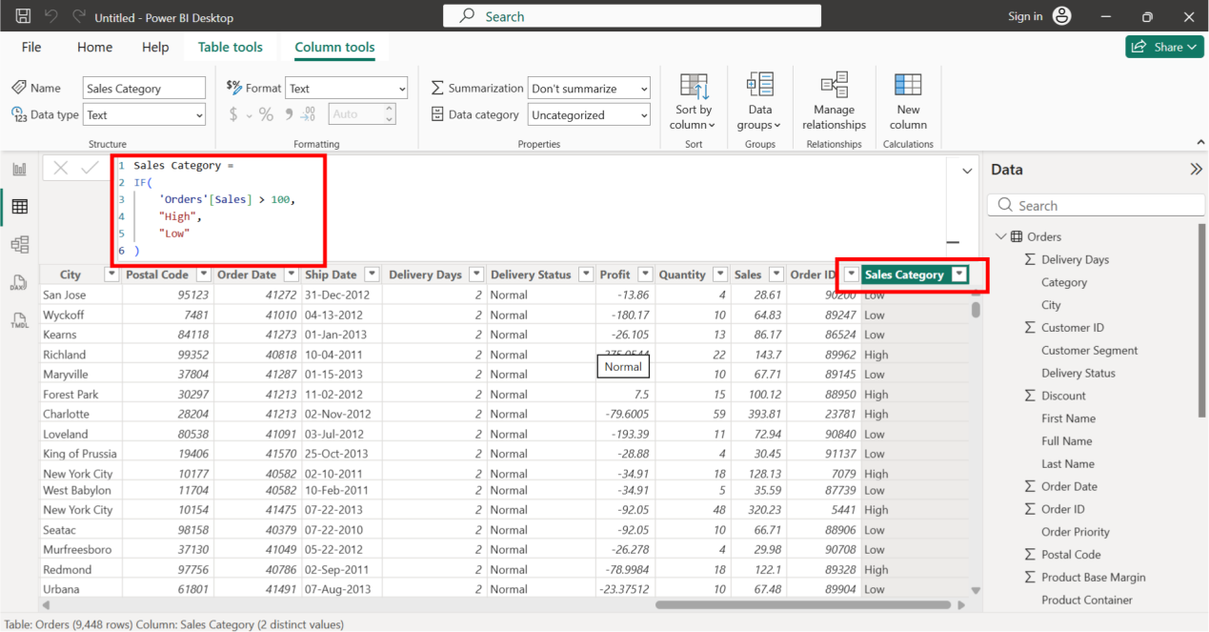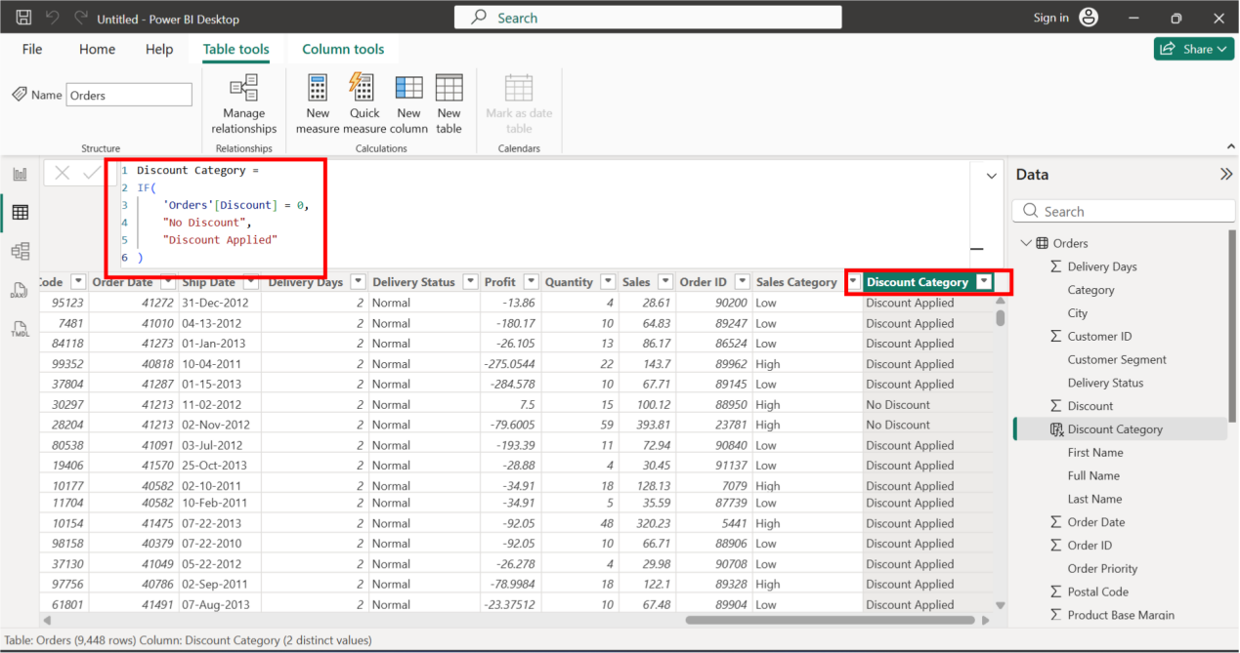

Task:
2. Create calculated measures:
• Total Sales (Sum of Sales)
• Total Orders (Count of Order ID)
• Total Revenue (Calculate by multiplying Quantity with Unit Price using a SUMX iterator
function.)

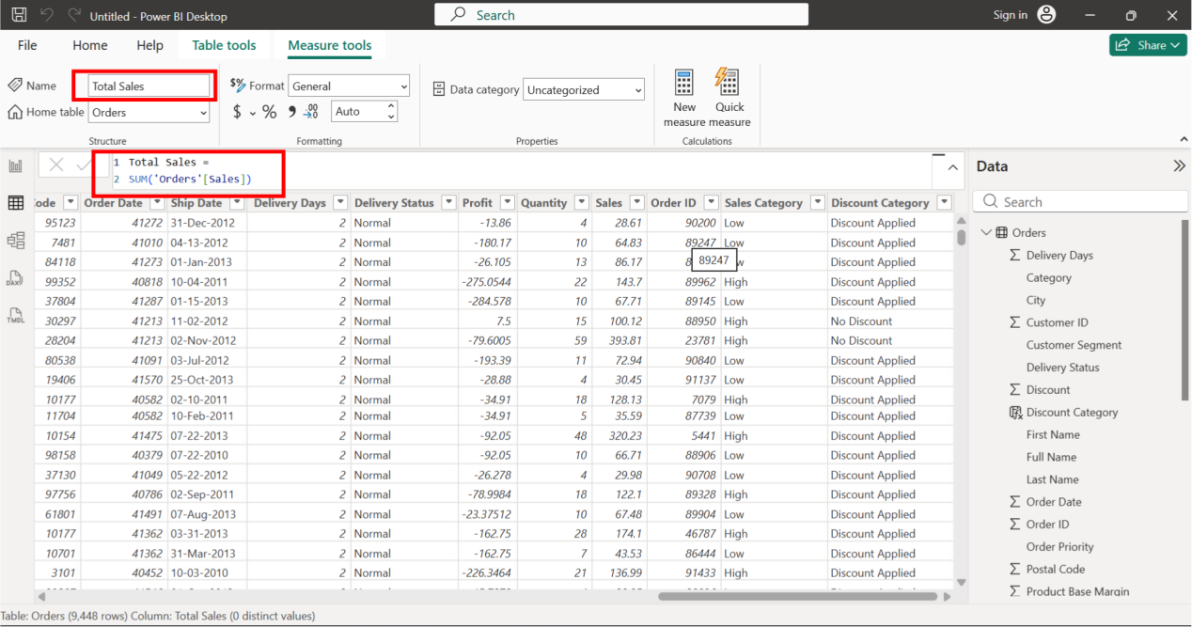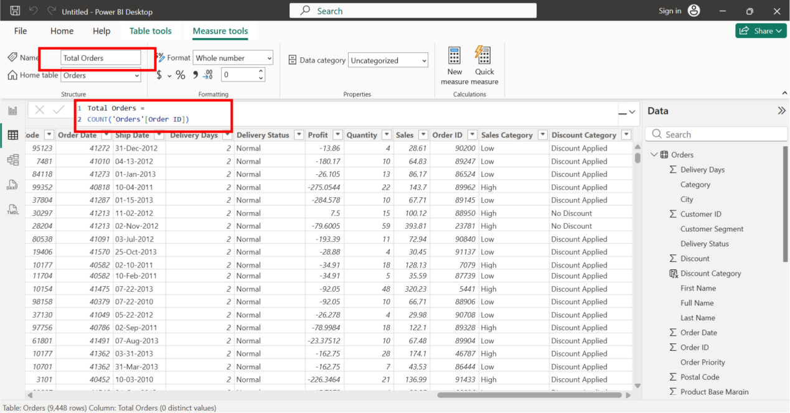

Thrid one is :
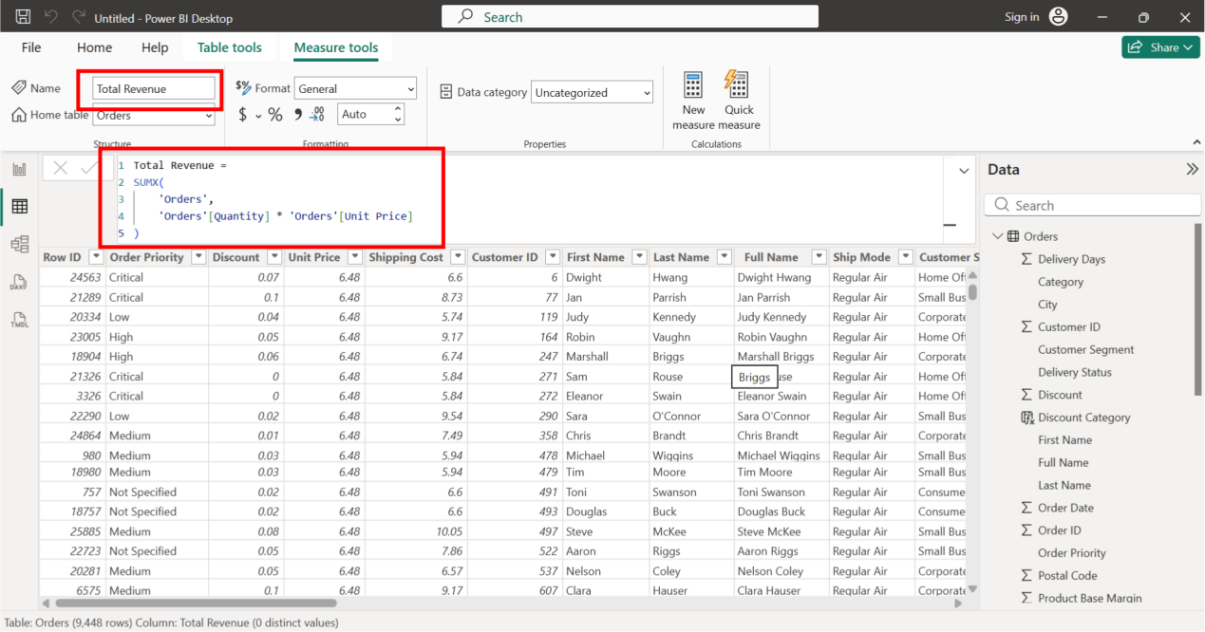

Task:
- Validate all the results of calculated measures by using the Matrix visual.

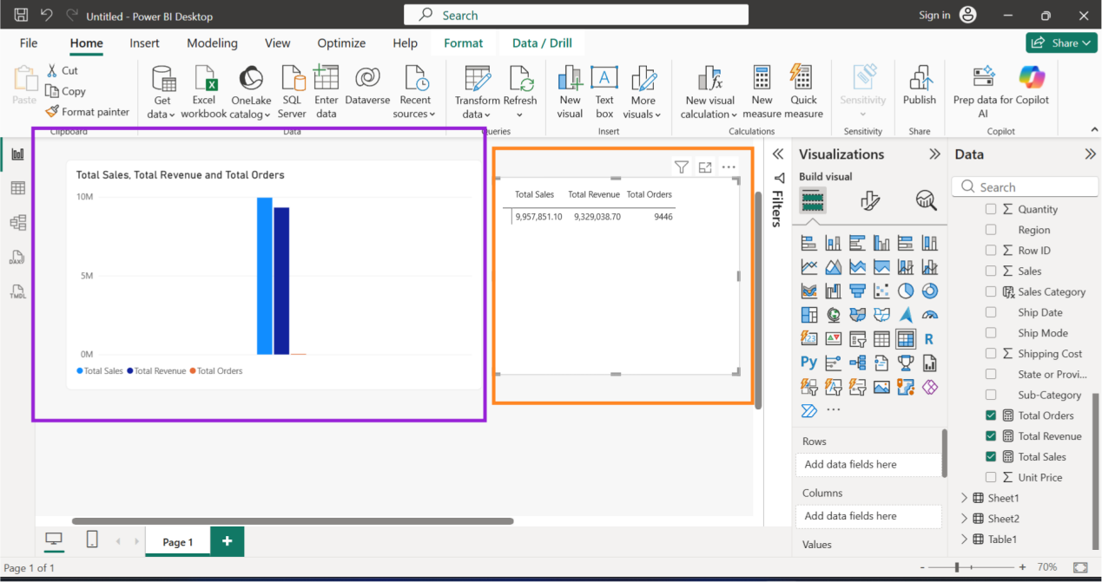

Thanks

